Incident Technical Report: Sliding Bearing Failure in Starboard Propulsion Shaft of Naval Vessel (September 2014)

Executive Summary
On September 17th, 2014, during routine sea operations in the Eastern Mediterranean, a mechanical failure occurred in the sliding bearing supporting the starboard propulsion shaft of a naval vessel. The failure was indicated by abnormal vibration patterns, a progressive rise in temperature, and eventually audible knocking accompanied by metal-to-metal contact between the shaft and the bearing housing. The mechanical crew initiated an immediate on-sea response to prevent catastrophic damage to the propulsion system and potential risk to the crew. After switching to safe mode, the vessel returned to base at a controlled speed, where disassembly was conducted at the dock.
The investigation determined that the failure was caused by shaft misalignment and loose bearing mounting bolts, which led to excessive friction and vibrations. The damaged bearing was sent to a certified laboratory for metallurgical analysis. This report outlines the incident timeline, system behavior, response measures, and engineering conclusions along with critical maintenance updates and recommendations for future monitoring.

Pre-Departure System Checks (04:30–05:30)
Before departure, the vessel’s mechanical division conducted a thorough pre-operational inspection in line with naval engineering protocols for propulsion system readiness. The inspection began at 04:30 and focused on the following key areas:
- Lubrication System Status: The lubricant level in the reservoir was recorded at 88% of total capacity, indicating sufficient supply during operation. The fluid in use was ISO VG 220 synthetic marine lubricant, and its visual inspection revealed no signs of contamination, discoloration, or degradation. The lubrication system features dual pumps and automated thermal bypass valves, ensuring continuous and reliable delivery of lubricant to the sliding bearing housing.
- Mechanical Mounting and Bearing Interface: Two days before departure, the engineering team inspected the preload on the mounting bolts securing the bearing housing to the ship’s internal bulkhead using a calibrated digital torque wrench. All sixteen bolts were confirmed to be within 5% of the specified 240 Nm torque.
- Instrumentation and Sensors: Vibration sensors (two accelerometers, one axial accelerometer mounted on bearing housing) were recalibrated and tested for electrical continuity. The inertial measurement unit (IMU), which monitors dynamic anomalies in the shaft, was reset and its sampling frequency verified.
- Static Condition Inspection: Before engine startup, the team conducted a visual inspection to ensure there were no seawater or lubricant leaks—none were detected. Shaft alignment was visually assessed for signs of deformation, and both the shaft supports and thrust bearings were confirmed to be securely mounted. The shaft was manually rotated and showed no signs of excessive resistance.

Initial Shaft Startup and Departure (05:30–06:15)
At 05:35, following full clearance from the Chief Engineer, the engines were started. Main propulsion systems were engaged, with both port and starboard shafts activated. No abnormalities were detected.
At 05:50, the vessel departed the naval base, and both shafts were brought up to the nominal 1800 RPM. The starboard shaft, fitted with the sliding bearing under discussion (bearing model: MKB-245 white-metal hydrodynamic bearing, support type, 160 mm diameter journal), operated within normal thermal parameters. The lubricant outlet temperature stabilized at 57.8°C, and the inlet temperature measured 48.5°C, indicating normal heat transfer and lubricant flow. Lubricant pressure remained steady at 72 psi, with minor oscillations attributed to pump cycling.
At 06:00, vibration readings from a single axial accelerometer mounted on the bearing housing showed RMS acceleration levels of 0.031 g—consistent with historical baseline values. No abnormal noises were reported, and the propulsion shaft exhibited smooth and balanced rotation.

Routine Monitoring at Sea (06:15–07:10)
From 06:15 onwards, the on-duty engineering technician conducted hourly system reviews. Logged parameters included:
- Lubricant visual inspection: The lubricant was checked for clarity, absence of foreign particles, and no signs of leakage. Lubricant level remained stable.
- Temperature monitoring: Inlet and outlet temperatures were recorded at 48.5°C and 57.8°C, respectively, with a manually calculated differential of approximately 9.3°C, remaining within the expected operating range.
- Vibration monitoring: Real-time vibration data were reviewed via the Integrated Monitoring Panel (IMP). The RMS acceleration measured by the axial accelerometer on the bearing housing showed a gradual increase from the nominal 0.031 g to 0.045 g. Although the trend was noted, the increase was too minor to trigger automated alarms.
- Visual shaft inspection: The technician confirmed that the shaft was rotating smoothly, with no visible abnormalities or audible irregularities such as knocking or rubbing noises.
At 07:10, a subsequent check recorded an RMS vibration level of 0.068 g. While still below the predefined cautionary threshold of 0.080 g, the increase was steeper than typical baseline fluctuations. The IMP flagged the value as a "watch item." Upon reviewing the previous five days of logged vibration data, the technician found no comparable upward trend.

Emergence of Anomalies (07:10–07:30)
At 07:15, the on-duty technician reported a mild knocking sound originating from the starboard bearing housing area. He immediately alerted the bridge and requested a reduction in shaft RPM to verify the nature of the vibration under lower load conditions.
At 07:20, while positioned near the inspection hatch, the technician confirmed rhythmic mechanical knocking consistent with intermittent contact between the shaft and the bearing shell. The frequency of the sound matched the shaft’s rotational speed, suggesting synchronized mechanical interference.
Simultaneously, the lubricant outlet temperature increased to 68.3°C, rising sharply from the previously stable 57.8°C. Localized thermal imaging revealed a developing hot spot on the lower quadrant of the bearing housing, indicative of abnormal frictional heating.
Vibration data showed an axial acceleration of 0.095 g—over 200% higher than the nominal baseline of 0.031 g. The Integrated Monitoring Panel flagged the condition as exceeding cautionary limits.
By 07:30, the engineering team escalated the situation to Operational Alert Level 1, marking the onset of mechanical degradation and initiating containment and diagnostic procedures.

Emergency Isolation Procedures (07:30–07:50)
At 07:35, upon receiving authorization from the Engineering Officer of the Watch, the engineering team initiated the following mitigation steps:
- Shaft RPM Reduction: Starboard shaft speed was gradually reduced from 1800 to 500 RPM over a three-minute period via controlled propulsion input.
- Lubrication System Rerouting: The lubrication system was switched to the secondary circulation loop to isolate the primary filter, which was suspected of partial blockage or contamination.
- Auxiliary Cooling Activation: The auxiliary seawater flushing system was activated to enhance heat dissipation from the bearing housing.
- Clutch Disengagement: The starboard shaft clutch was disengaged to enable free rotation in emergency limp mode.
- Load Redistribution: Propulsion load was fully transferred to the port shaft, allowing continued navigational control.
Despite these actions, vibration levels continued to escalate, reaching an RMS acceleration of 0.145 g—a significant increase from earlier readings. Lubricant outlet temperature exceeded 80°C, and the audible knocking from the bearing housing intensified in both volume and frequency.

Controlled Return to Port (07:50–10:15)
At 07:50, following confirmation of mechanical degradation, the starboard engine was shut down, and the shaft was mechanically locked by "Shaft Lock Protocol". From this point forward, the shaft remained secured and non-operational. The vessel continued its return to Haifa Naval Base using only the port propulsion system, maintaining reduced speed under controlled navigation, and the speed was 10 knots. At 10:15, the vessel arrived safely at the dock with tugboat assistance.

Initial Mechanical Inspection at Shipyard (10:30–12:30)
At 10:30, the vessel was lifted at the shipyard platform to allow safe access for inspection and repair operations. The mechanical crew, along with mechanics from the mechanical laboratory, secured the starboard shaft using adjustable support brackets and safety blocks. Lubrication system was fully isolated in preparation for disassembly. At 11:00, work on the bearing housing began. Removal of the upper bearing shell revealed extensive scoring and blue discoloration on the white-metal surface, indicative of localized overheating. Visual inspection identified wiped zones—typical of hydrodynamic film collapse. At 12:30, the lower bearing shell was extracted. The surface displayed spalling and clear evidence of thermal fatigue damage.

Laboratory Analysis of the Damaged Bearing (13:00–14:30)
At 13:00, the damaged MKB-245 bearing shells were delivered to the Naval Engineering Laboratory. A comprehensive metallurgical investigation included:
- SEM (scanning electron microscopy) showing micro-crack formation and fatigue bands.
- EDS (energy-dispersive spectroscopy) confirming elevated iron and copper levels in wear zones.
- Hardness testing, showing decreased Brinell values in the high-temperature regions.
- Cross-sectional micrograph analysis showing shear deformation across grain boundaries.
- In addition, Photographic inspection proved to be the earliest and most sensitive method for detecting the onset of wear.
- Image-based measurements (e.g., depth, area loss, surface roughness) should be quantified where possible, not just qualitatively assessed
The root cause was determined to be a loss of hydrodynamic film due to eccentric shaft loading. Secondary contributors included one mounting bolt discovered post-failure to have <60% of required preload, likely leading to partial bearing tilt.

Replacement Bearing Installation and Realignment (13:00–16:45)
After removal of the failed bearing and its dispatch to the laboratory for analysis, preparations commenced at 13:00 for installation of the replacement unit—an identical MKB-245 white-metal hydrodynamic sliding bearing, intended for combined axial and radial loads in continuous marine operation. By 13:45, the shaft journal was cleaned and subjected to non-destructive testing, including magnetic particle inspection (MPI) and dye penetrant examination, to ensure the absence of cracks or material discontinuities. No structural defects were identified. At 14:15, journal roundness and runout were measured using a precision dial indicator. The recorded roundness deviation of 0.04 mm conformed to manufacturer tolerances. Subsequently, the replacement bearing shell was coated with molybdenum disulfide (MoS₂) dry film lubricant and installed into the pre-cleaned housing. Mounting bolts were torqued to 240 Nm in a cross-pattern sequence using a calibrated digital torque wrench to ensure uniform preload. At 15:30, shaft alignment was recalibrated using a laser optical alignment system. Angular misalignment was corrected by 0.17°, and radial offset was reduced to less than 0.08 mm compared to pre-repair values. By 16:30, the lubrication system was flushed with solvent and replenished with fresh ISO VG 220 oil. Concurrently, seawater cooling circuits were re-pressurized, and all temperature and pressure sensor loops were recalibrated to restore operational readiness.

Post-Installation Testing and System Verification (18:15–20:15)
At 18:15, a controlled startup procedure was initiated. The shaft was rotated at a neutral speed of 800 RPM for 15 minutes to evaluate frictional behavior and monitor the bearing’s thermal response. Infrared thermography confirmed uniform heat distribution across the bearing housing, with no signs of localized overheating.
At 18:45, the vessel went for a trial outside of the naval base, and the shaft was accelerated to full operating speed (1800 RPM). A single-axis accelerometer mounted on the bearing casing recorded RMS vibration levels of 0.045 g—well below the alert threshold.
Simultaneously, lubricant sample analysis confirmed lubrication system cleanliness, with ISO 4406 contamination levels measured at 15/13/10.
To assess axial stability, the system was operated in reverse rotation. Axial thrust measurements remained within the limits, indicating stable bearing response.
At 19:15, the propulsion system was engaged under moderate load (50%) for a 20-minute operational trial. Throughout the run, all monitored parameters—including vibration, temperature, shaft displacement, and lubricant flow—remained stable. The bearing reached thermal equilibrium at an outlet temperature of 56.7 °C.
System performance was continuously recorded by the integrated monitoring panel. No warnings, fault indicators, or abnormal trends were observed during the testing period.

Crew Debrief and Internal Investigation Summary (20:15–21:15)
A technical debrief was held by the chief engineer and failure analysis team:
- Timeline Review: 20-minute response between anomaly detection and propulsion reduction. Protocols followed.
- Risk Assessment: Continued operation beyond 08:00 could have led to seizure.
- Root Cause: Preload loss in mounting bolt caused shaft tilt and lubrication breakdown. Emphasized validating preload under live conditions.
- Sensor Gaps: Monitoring system escalated too late. Future designs should integrate vibration, temperature, and acoustic data fusion for early detection.

Recommendations
- Vibration Monitoring Enhancement: It is recommended to re-evaluate alert thresholds and perform silent system tests to monitor accelerometer output at rest. The difference in baseline DC levels before the failure and during the trial suggests this could improve early fault detection.
- Alignment Verification Protocol: Implement mandatory shaft alignment measurements prior to departure using laser or dial indicator tools. Visual inspection alone is insufficient.
- Bolt Torque Monitoring Procedures: Establish a tracking protocol for bolt torque history and consider periodic re-torque checks, especially after drydock or major maintenance periods.
- Training and Response Drills: The crew’s quick and effective response during the failure scenario was commendable. Continued emphasis on training and emergency simulation drills is essential to maintain high readiness
- Establish a wear progression model linking image-based wear depth to vibration features (RMS increase, sideband growth, harmonic distortion).
- Use this model to predict the remaining useful life (RUL) of the gear before catastrophic failure.

Gaps Identified During Investigation
- Delayed Alert Escalation: The monitoring system recorded elevated vibration values but issued alerts only after degradation had significantly progressed.
- Unclear Bolt Release Mechanism: Although bolts were torqued per protocol prior to deployment, at least one was found to have lost significant preload. The exact mechanism of preload loss remains undetermined and represents a critical investigative gap.
- Lack of Alignment Measurement: No alignment measurement was performed prior to departure—only a visual inspection was conducted. The absence of quantitative shaft alignment verification likely contributed to the angular deviation that developed during operation.
- Insufficient Baseline Comparison Logic: The IMP flagged elevated vibration as a "watch item" but did not correlate it against historical operational data. This limited the crew’s ability to contextualize the anomaly and respond earlier.

Conclusion
The failure of the MKB-245 sliding bearing on the starboard propulsion shaft was primarily the result of preload loss in at least one of the bearing mounting bolts. This loss of clamping force likely caused angular shaft deviation, degradation of the hydrodynamic film, and the onset of metal-to-metal contact. While the root cause of bolt loosening remains unclear, the event highlights the importance of mechanical joint integrity and alignment verification.
Thanks to the timely detection by the engineering technician and prompt mitigation by the crew, catastrophic damage was avoided. Post-failure analysis, repair, and re-commissioning were conducted methodically and restored full operational capability. Future reliability will depend on implementing the recommended monitoring improvements, adopting more rigorous alignment practices, and maintaining a high level of operational preparedness.
There are

Table 1: Predeparture Checklist
What to do | Check/UnCheck
Lubrication System | CHECK
Interface | CHECK
Instrumentation and Sensors | CHECK
Condition Inspection | CHECK

Table 2: Reviews during sailing
Time | Notes
05:35 | Start on
06:00 | No abnormal
06:30 | No abnormal
07:00 | No abnormal
07:10 | High RMS but normal
07:30 | Alert Level 1

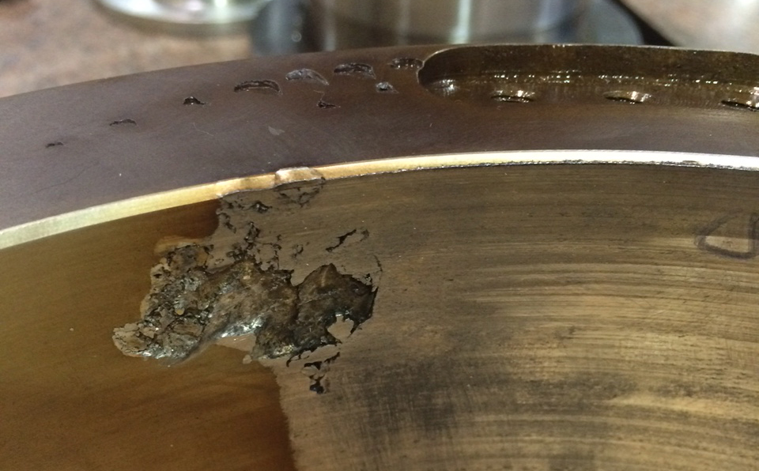
Figure 1: The failure bearing.

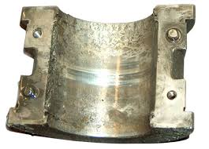
Figure 2: Failure bearing housing.
As observed, the bearing was worn out.
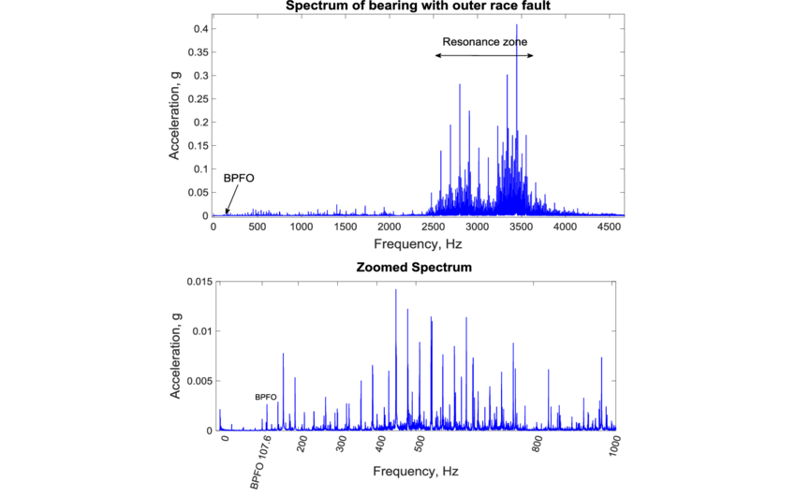
Figure 3: Vibration signal spectrum during failure.
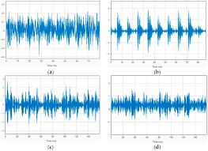
Figure 4: Vibration signal zoom in to observe the abnormalities.

Implement Alarm Escalation and Response Drills
- Define clear escalation rules when RMS or sideband thresholds are exceeded, ensuring rapid decision-making.
- Conduct operator training to interpret early-warning signs in both images and signals, enabling timely shutdown or controlled load reduction.

Improve Data Acquisition and Analysis Tools
- Automate the synchronization of image data and vibration signals into a single diagnostic report.
- Incorporate AI-driven feature extraction from images (surface crack detection, pitting quantification) to support objective, repeatable assessments.
- Store all monitoring data in a central database to enable trend analysis and long-term system health assessment.

Schedule Post-Failure Review Protocols
- After any future gear replacement or failure, conduct structured reviews that combine metallurgical inspection, vibration records, and photographic analysis.
- Lessons learned should feed back into threshold calibration and preventive strategies.

Overall Recommendation:
A dual-path monitoring framework should be adopted, where visual inspection detects the earliest onset of wear, while vibration analysis tracks its progression and severity. Proactive thresholds and predictive modeling must guide intervention well before the transition into severe wear, thereby avoiding unexpected catastrophic failures.

